Math 1211 Discussion Assignment 4

**Write an example of a function whose derivative can be found by using the following rules:**

a) Product rule and special function differentiation rules

b) Power rule, quotient rule, and chain rule

c) Chain rule twice

d) Implicit differentiation and special function differentiation rule

1. **Product rule**

The product rule calculates the derivative of two function about x like

f(x) and g(x)



Example

To find derivative of f(x) = (x+2) (2x-1)

$$\frac{dy}{dx}={\left(x+2\right)}^{'}\left(2x-1\right)+\left(x+2\right){\left(2x-1\right)}^{'}$$

$$=2x-1+2x+4=4x+3$$

According to (Differentiating Special Functions – Calculus Tutorials, n.d.),

**Special function differentiation rules as below**

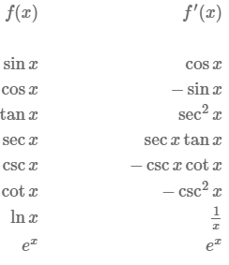

Image from (*Differentiating Special Functions – Calculus Tutorials*, n.d.)

Example

1. F(x) =ex, then f’(x)= ex
2. F(x) = csc(x)+ xtan(x)

F’(x)=-cscxcotx + tanx + sec^2(x)

1. f(x)= lnx, f’(x)= 1/x
2. **Power rule, quotient rule, and chain rule**

According to (*3.3 Differentiation Rules - Calculus Volume 1 | OpenStax*, n.d.)

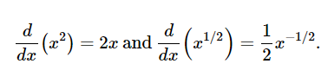

Power Rule Example

$$\frac{d}{dx}x^{3}=3x^{2}$$

Quotient Rule

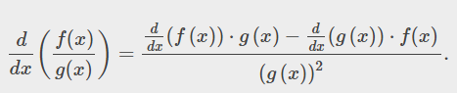

Example

F(x)= $\frac{3x^{2}+2}{4x+3}$ = $\frac{6x\left(4x+3\right)-4(3x^{2}+2)}{{\left(4x+3\right)}^{2}}$ = $\frac{12x^{2}+6x-8}{{\left(4x+3\right)}^{2}}$

Chain Rule

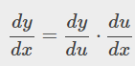

Example

H(x) = (2x2 + 2x)2

H’(x) = 2(2x2+2x) (4x+2) = 2(8x3+4x2+8x2+4x) = 16x3 +12x2+8x

1. Chain rule twice

According to (3.6 The Chain Rule - Calculus Volume 1 | OpenStax, n.d.),





G(x)=7x2+1

H(x)=cosx

F(x)=x4

K’(x) = 4(cos(7x2+1))3 (-sin(7x2+1))(14x)

= -56xsin(7x2+1) cos3(7x2+1)

1. Implicit differentiation and special function differentiation rule

Assuming that y is defined implicitly by the equation

X2+y2=25, find $\frac{dy}{dx}$ .

$\frac{{d(x}^{2}+y^{2})}{dx}$ = $\frac{d(25)}{dx}$

2x + 2y $\frac{dy}{dx}$ = 0 then $\frac{dy}{dx}= -\frac{x}{y}$

Reference

*3.3 Differentiation Rules - Calculus Volume 1 | OpenStax*. (n.d.). Retrieved September 18, 2022, from https://openstax.org/books/calculus-volume-1/pages/3-3-differentiation-rules

*3.6 The Chain Rule - Calculus Volume 1 | OpenStax*. (n.d.). Retrieved September 25, 2022, from https://openstax.org/books/calculus-volume-1/pages/3-6-the-chain-rule

*Differentiating Special Functions – Calculus Tutorials*. (n.d.). Retrieved September 25, 2022, from https://math.hmc.edu/calculus/hmc-mathematics-calculus-online-tutorials/single-variable-calculus/differentiating-special-functions/